- Oak (quercus rober)
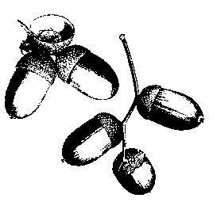

This is the classic ‘English oak’. It has a think strong trunk with criss-crossed crevices in the bark. Several of the branches have a characteristic zigzag shape

The easy-to-identify leaves have several semi-circular ‘lobes’. In the summer green acorns start to form, which turn brown and are dropped in late autumn.

The wood of the oak tree is strong. It is used for building furniture and beams for buildings. In the olden days most ships were built of oak, and the tree became quite scarce as so many were used for shipbuilding.

- Giant Redwood (sequoia giganteum)

Also known as Wellingtonia, this coniferous, evergreen tree is easily spotted by its soft, spongy red bark and its tall, narrow cone shape.

At 84m a giant redwood in California is the tallest tree in the world. By comparison the Finsbury Park ‘giant’ redwood is a very small example of this tree!

- Black Pine (pinus nigra)

The black pine is an evergreen tree with long thin needle-like leaves that grow in pairs. The pinecones can be seen higher up the tree, green initially but turning brown as they become ready to drop. The bark has a rough texture and is more grey than black. This type of tree can grow to a height of 30m.

- Silver Birch (betula pendula)

The silver birch is easily identified by its white (or silver) papery bark and thin dangling branches that blow gently in the breeze in the summer. The leaves are triangular and pointed with jagged edges. The bark of older trees starts to crack and forms white diamond shaped areas on a woodier dark trunk.

- Holly (ilex)

The holly is another evergreen tree. There are two here. One is variegated, meaning it its leaves are green and white. The other is green only. Holly leaves are usually prickly. This is to stop wild animals from eating them. Trees that are regularly pruned, like this green one, tend to lose their prickles as they ‘know’ they won’t be eaten.

In winter, holly has clumps of pretty red berries but don’t eat them as they are poisonous.

- Cherry (prunus)

The cherry tree is often planted in parks and residential streets because its blossom is so pretty in the spring. It is easily spotted by the horizontal bands of lighter and darker bark.

Cherry trees tend not to be more than 5-10m high. The leaves tend to be thin with a jagged edge and a distinct point at the tip. The fruit is a cherry but ornamental trees like this one don’t produce tasty fruit.

15. Lime (tilia)

Despite its name the lime tree does not produce edible, green citrus fruits. In fact its fruit pods look more like peas. You may be able to see them in summer.

The leaves are broad and pointy. Often lime trees have lots of shoots (called suckers) growing near the ground or from patches higher on the trunk.

In the summer lime trees often drip a sticky substance called ‘honeydew’ which can make a mess of your car if park under one.

Hornbeam (carpinus)

This handsome tree has a very distinctive shape in winter once the leaves have fallen.

The leaves are oval and pointed with a double-jagged edge. Usually the trunk is dark, smooth and veiny.

The hornbeam is a very traditional British tree. It is often found in ancient woods (such as Queen’s Wood in Highgate). In the past it was ‘farmed’ for firewood by regular coppicing. Nowadays the very hard wood is more likely to end up as a chopping board or for the hammers inside a piano.

Finsbury Park Tree Trail

This tree trail is brought to you by the Friends of Finsbury Park.
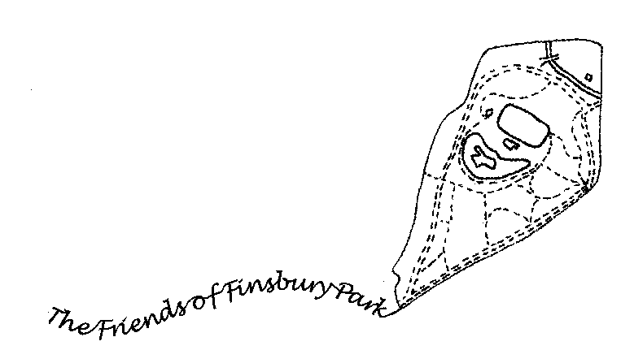

We wanted to introduce you to some of the trees in the park, and help you to spot some of the more common trees you might see elsewhere.

There are 16 trees in the trail. They each have a numbered post telling you what type of tree it is. This guide gives you a bit more information about each tree and a map showing the location of each tree. The trail starts outside the café next to the boating lake.

It is about a mile in length and can be walked in 20-25 minutes, allowing time to stop and appreciate each tree.

We hope you enjoy our trail. Please give us feedback via our Facebook group or tweet us @FinsParkFriends. Or e-mail us at thefriendsoffinsburypark@gmail.com.

* * * * *
Suggestion: Try walking the tree trail at different times of the year to see the trees with and without their leaves, and to see their buds, their blossom, their fruits and their autumn colours.

1. Plane (Latin name is platanus)

Known as the London plane this is the most common tree in the park. It is often found in residential streets and squares in London. Many of the trees in the park are well over 20m high. The bark tends to be patchy with different shades of yellow and brown. Flaky bark is the sign of a healthy plane tree!

The trunk of this tree is tall and wide, but many of the other plane trees have lumps and carbuncles on their trunks. The large leaves mostly have five lobes. In the winter look out for the round fruits that cling stubbornly on after the leaves have dropped.
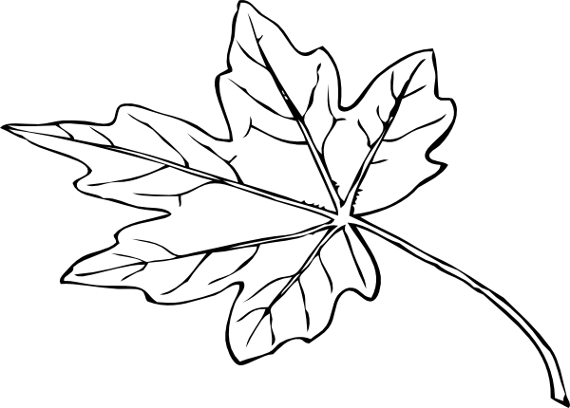

- Lombardy Poplar (populus)

This twin-trunked tree is not typical as the poplar is usually an elegant, narrow column-shape. The leaves are triangular in shape. There are 30 different species of popular. This one is native to Italy, but it seems perfectly happy in Finsbury Park.

Poplar wood is good for woodworking and is commonly used to make industrial pallets.

MAP GOES HERE

3. Willow (salix)

The weeping willow likes to have its roots in water, which is why you often find it near ponds and lakes like this one. The smaller branches are yellow in colour. Unlike most deciduous trees (ones that lose their leaves in winter) the leaves are long and narrow.

Traditionally willow wood was used to make cricket bats and the bark is used to make aspirin.

4. Holm Oak (quercus ilex)

Unlike the English oak (number 9) the holm oak is an evergreen tree. It grows more naturally in southern Europe but is not unusual in parks in the UK.

The leaves are fairly smooth and oval shaped with a pointed end, while the bark is dark and cracked. Like all oaks, the holm oak has acorns which can be seen in the summer and which fall in the autumn.

In ancient Greece the leaves were used to tell the future and to make crowns to honour important people and heroes.
5. Cedar (cedrus)

This blue atlas cedar is also an evergreen. It is native to the Atlas mountains in Morocco in north Africa. The short, blue needles give the tree its distinctive colour.

You should be able to see big round cones higher up the tree at any time of the year.

6. Maple (acer)

The most common member of the maple family is the sycamore with its distinctive ‘helicopter’ seeds. This maple is an ornamental variety which also has helicopter seeds and glorious red and yellow leaves in the autumn.

The maple syrup you might pour over pancakes comes from its cousin, the Canadian sugar maple tree.

7. Horse Chestnut (hippocastanaceae)

The horse chestnut has distinctive big teardrop-shaped leaves grouped together on a single stalk. The upright flowers in spring are large and colourful, but the most famous feature of the tree is the brown, shiny conker inside a spiky case. Conkers tend to fall in September.
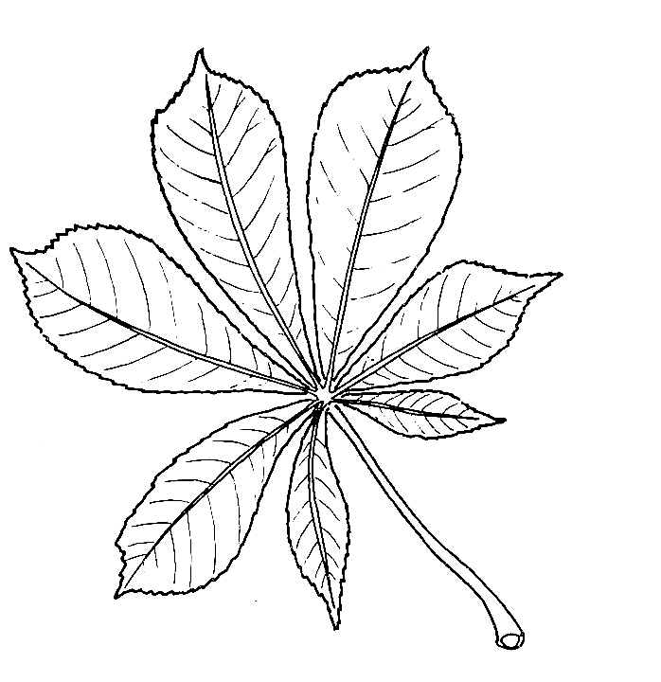
In late winter and spring look for the big,
sticky brown buds on upward pointing
twigs. These will eventually form hand-
some, large flowers in May.

8. Beech (fagus)

For such a big tree look how delicate the beech’s twigs are. The leaves too are delicate and oval in shape with a slightly wavy edge. But the beech is most easily spotted by its tall, straight, smooth grey trunk . You may think it resembles an elephant’s leg with its toes on the ground. Sadly this one has been the victim of people carving their names into its bark in the past. Not good!

The beech nuts are an edible treat in autumn. They are found inside the furry green burrs, but the Finsbury Park squirrels are unlikely to leave any for you to taste!

